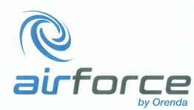

The Next Generation of Pulverizing is Here Today
In 2011, in an industry characterized by slow incremental change,
the team at Orenda Pulverizers were looking to disrupt the market.

MARKHAM, ONTARIO, CANADA - For most of the past 50 years, most manufacturers in the pulverizing industry seemed to be pleased with either the status quo or playing follow the leader. The status quo is familiar and easily understood. When problems or opportunities were discovered in the pulverizing market, manufacturers were content with tinkering rather than heading off boldly in a new direction.
The management and engineers at Orenda saw an opportunity. Orenda's pulverizers already had an established track record for producing consistently high-quality plastic powders for rotomolding, compounding, mixing, recycling, and other processes. But the company wanted to revolutionize pulverizing. They didn't just want to develop the most efficient and reliable machine on the market, they wanted to develop a pulverizer that their customers would be proud to own.
Three years later, in 2014 Orenda launched AirForce™ - a state- of-the-art pulverizer that was easier to use, safer to operate, more efficient, and more reliable. AirForce used air drawn into the mill housing to cool the mill and the material as it was being pulverized. Water cooling was no longer necessary. This eliminated the need for water towers, pipes, pumps, and chillers. The end result was a pulverizer with dramatically improved production rates while consuming approximately 50% less energy than conventional systems. In other words, the AirForce mill was nothing short of revolutionary.
In fact, manufacturers who have adopted the AirForce technology have seen significant benefits including higher efficiency, improved finished material quality, and reliability of operation. The highly efficient operation of this new generation of pulverizers minimizes the overall per pound cost of material produced. These reliable pulverizers need little operator attention and training.
AirForce technology has made it possible to pulverize materials that conventional pulverizers are not able to process efficiently.
Another benefit of the AirForce design is that cleanup time is minimal. Since the mill and discs remain cold, the melted resin does not bond to them. In the unlikely event of a melt occurring in the mill, the removal of the melted material is done quickly by hand without the use of tools. Additionally, because the bottom of the mill is fully enclosed, the area beneath the pulverizer remains free of powder and dust. Orenda boasts it is the only manufacturer that offers its pulverizers with a Quick-Clean option that reduces downtime for cleaning by at least 60%. This option makes it viable and cost-effective to use the same pulverizer to process different colored material.
As AirForce continued to gain traction in the market, the team at Orenda pursued further innovations. To ensure that its pulverizers met even the strictest safety rules of certain companies, the Orenda team, with the help of finite element analysis, was able to pinpoint areas of possible weakness in the design of pulverizers. With the safety of the operator in mind, Orenda redesigned its pulverizers to diminish accidents and to contain damage if a failure were to occur.
Fast forward to today and Orenda is again advancing pulverizing technology by leaps and bounds. The company recently introduced the next generation of its already best-in-class AirForce technology. In addition to increasing the airflow and airspeed for higher production efficiency, they improved upon their already high standards for quality and safety. But perhaps more important, is the fact that they have all but eliminated costly downtime with two new options available for adjusting the disc gap - the manual Quick Adjust, or the fully automated Smart Adjust AI.
Previously, adjusting disc gap would normally take 30 minutes or longer. If repeated several times a day, the cost associated with the downtime can be considerable. With Orenda’s new manual Quick Adjust feature, operators no longer need to stop the machine for time consuming adjustments. The operator just needs to turn a dial and the discs gap automatically adjusts as required. This innovative feature saves money and increases production.
Taking things another giant step forward, Orenda’s Smart Adjust AI (Artificial Intelligence) option represents the most sophisticated pulverizing innovation on the market ever. The AI module analyzes powder output continuously and accurately adjusts the disc gap. This eliminates constant powder sieve analysis in order to produce in-spec material. With the Smart Adjust AI, operator costs are greatly reduced and downtime is all but eliminated.
With a track record of real innovation, and on the heels of the latest technological breakthroughs, Orenda invites prospective customers to their lab to test their new AirForce pulverizers to evaluate the technology first-hand and see the dramatic improvements to their bottom lines.
With the latest AirForce technology, pulverizing has never been easier or more effective. The industry has been disrupted!
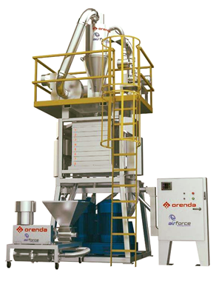
For further information about the AirForce and Orenda Technologies, please contact Orenda at 165 Steelcase Rd E, Markham, Ontario L3R1G1, Canada. Telephone 905.513.8043, sales@orenda-pulverizers.com or go to the website at www.orenda-pulverizers.com

